**SMART HARDWARE SHOP**

Below are the snapshot of front end,

1. Home page with list products and banner of news

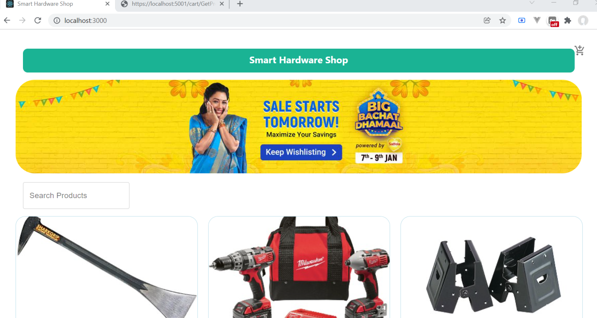

1. Click on add cart option to short list items to cart, click on cart icon to view your cart,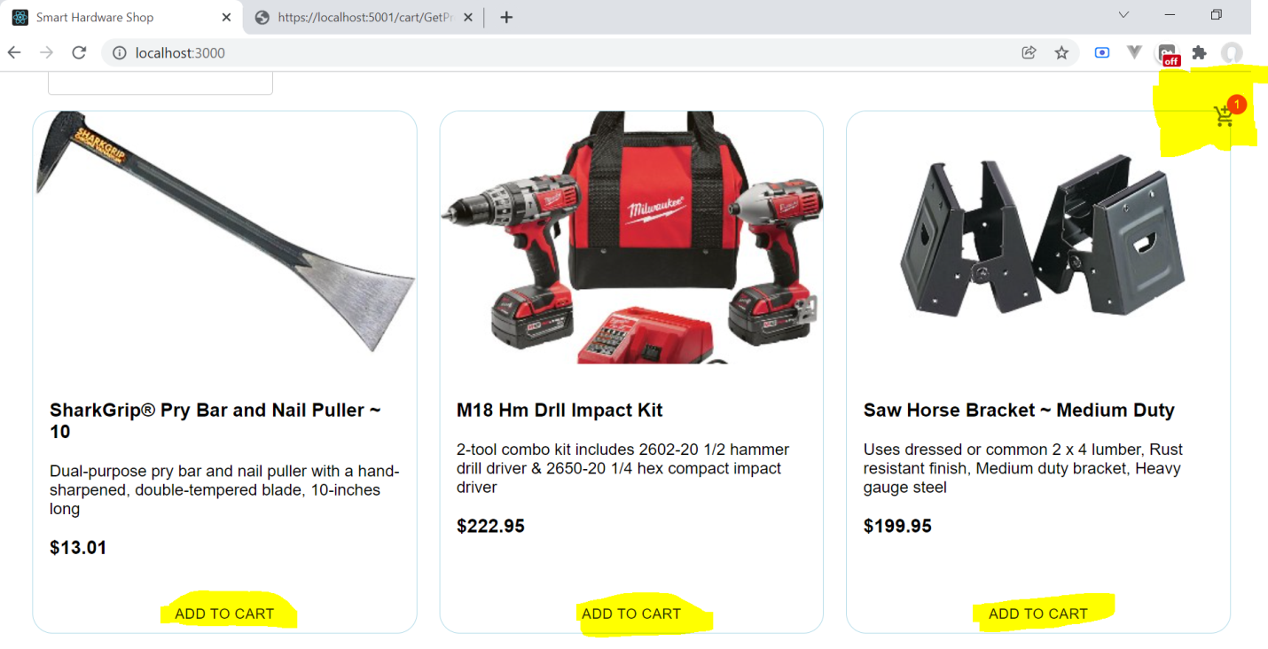
2. On click of cart icon, it shows all cart items which is added in cart. Here you can increase/decrease item numbers in cart.

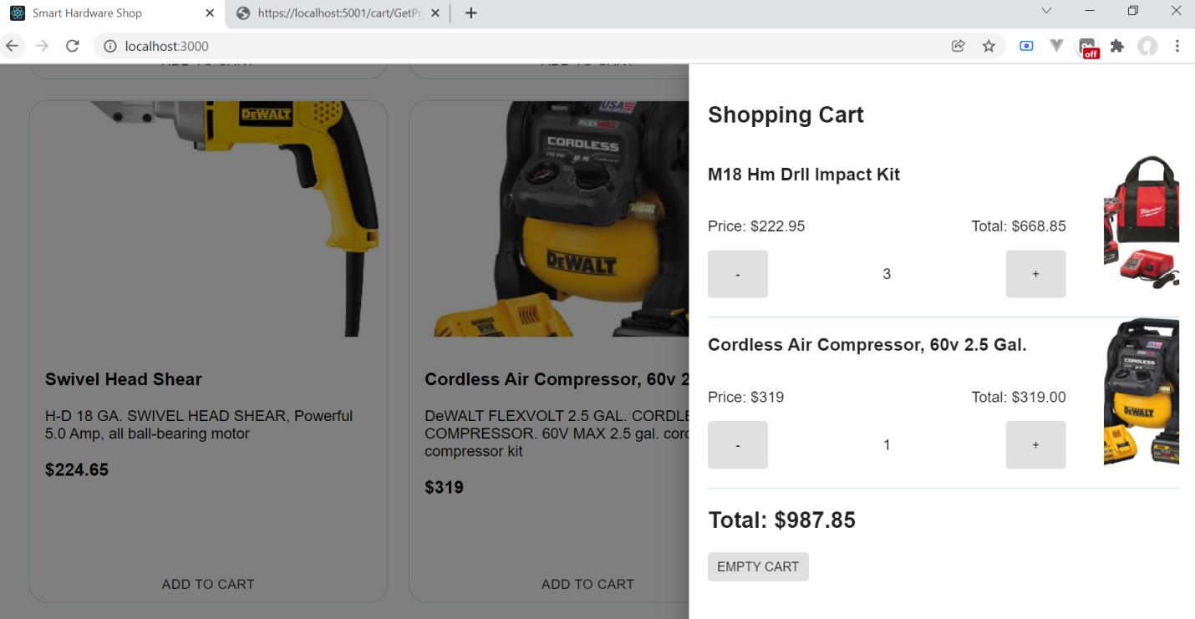

1. To empty cart click on empty cart button as shown below,

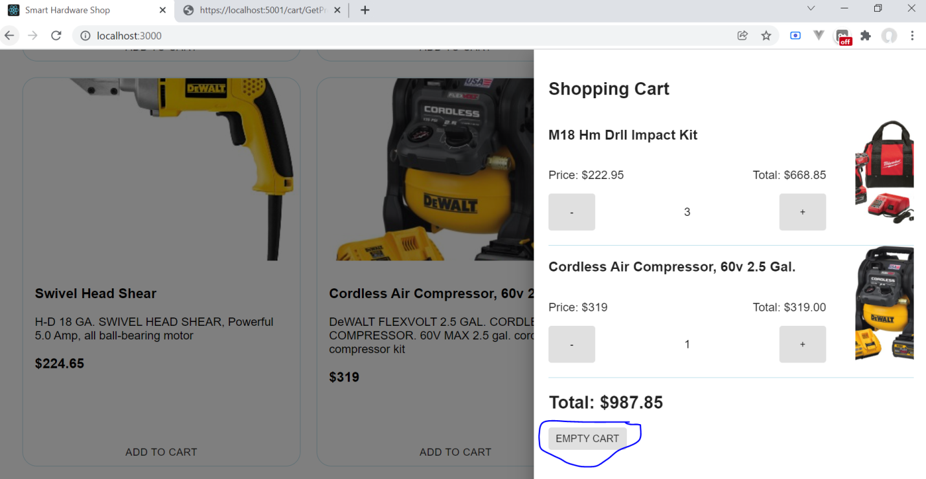

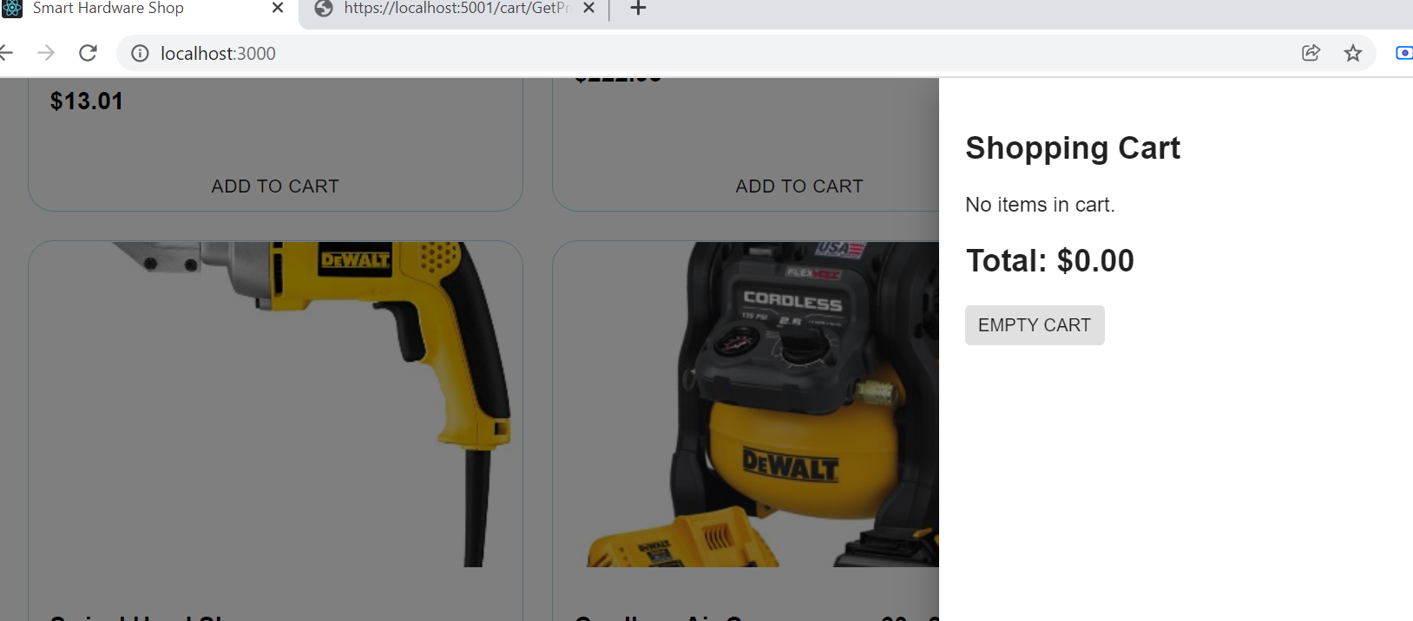

1. To search item, enter product details in search text box. But right now , search functionality is not completely implemented. Search functionality has some issue in LINQ query in API.

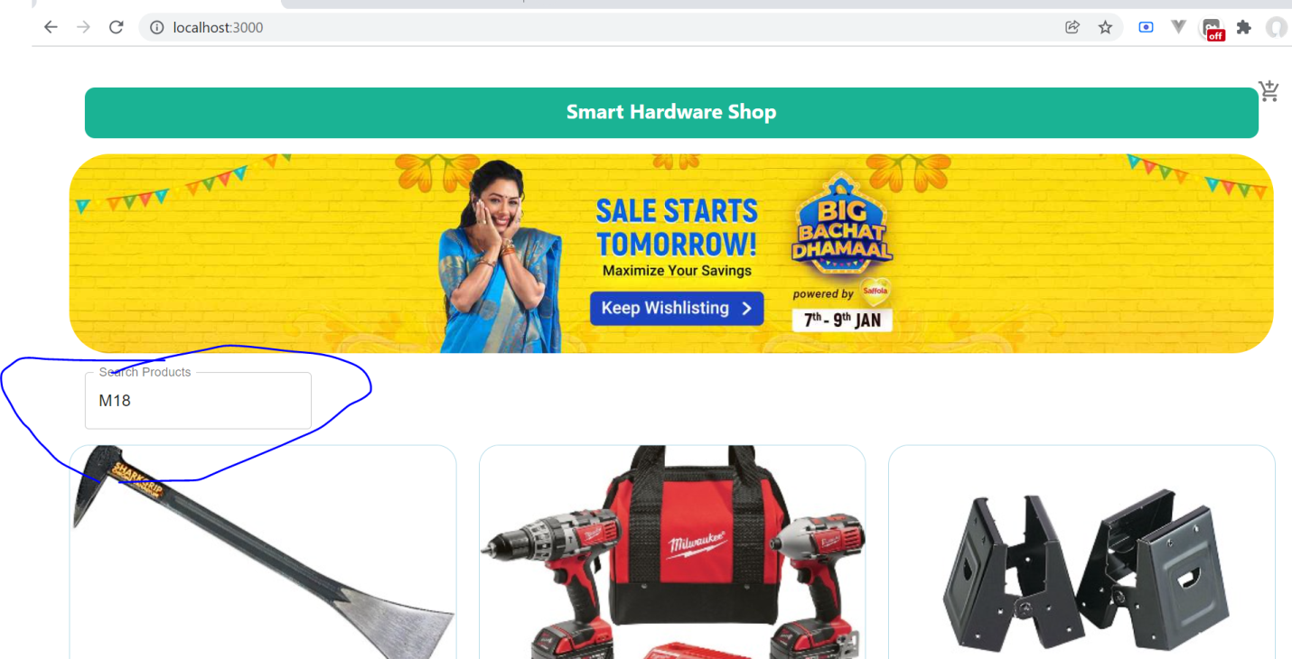

1. API access in below url,

<https://localhost:5001/cart/GetProductList>

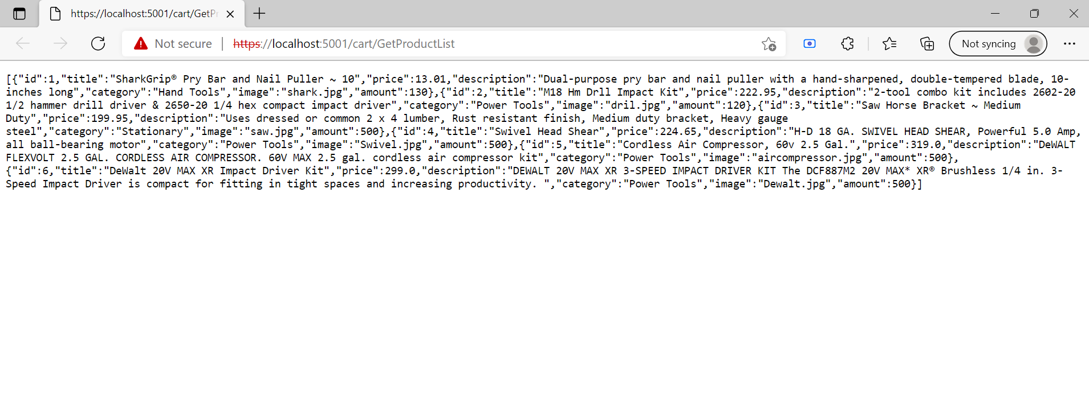

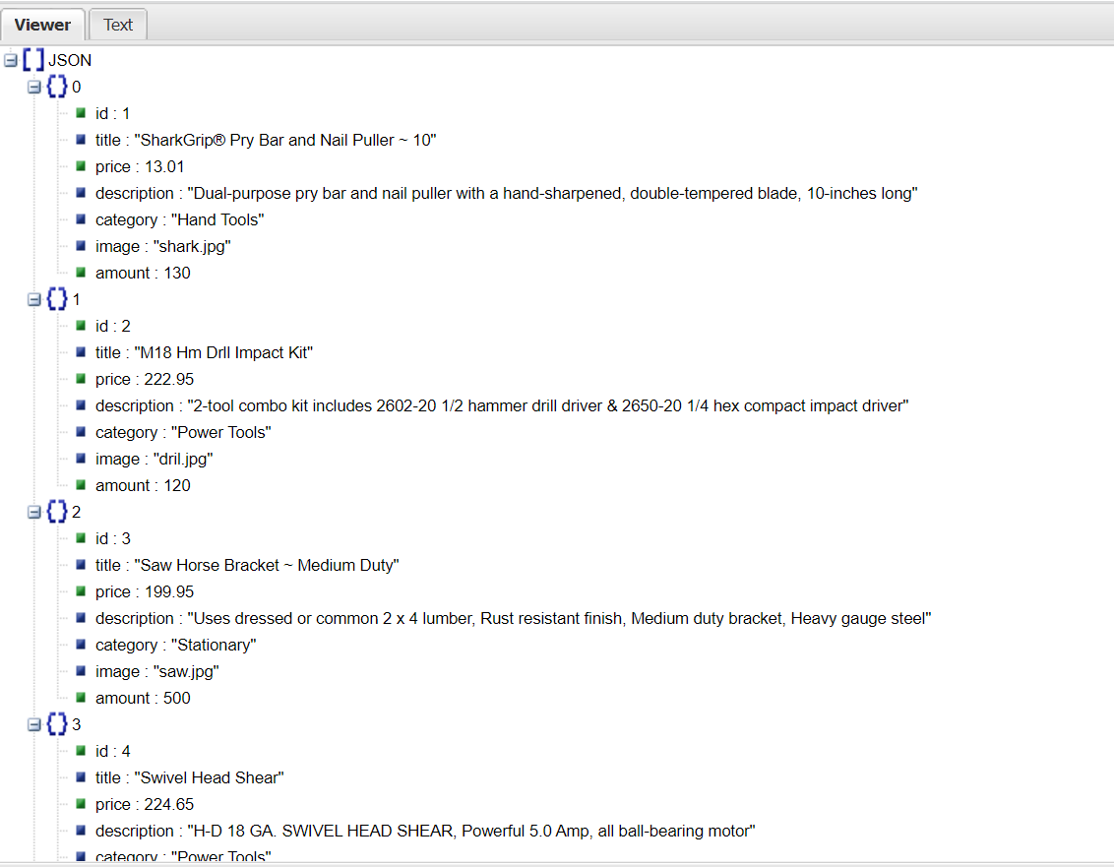

**Run smart-hardware-shop application:**

Find below instructions, you can find same details in Readme.md file,

Two folders

- smart-hardaware-shop-ui

    contains for frontend code and test cases(Jest, Enzyme)

- smart-hardaware-shop-api

    contains backend api code and test cases(Nunit testing)

Both solutions contians unit test cases

To run appllication,

**# smart-hardware-shop-ui**

-Open folder "smart-hardware-shop-ui" in visual code, right click on 'smart-hardaware-shop-ui' folder and select 'open integrated terminal'

- to run ui use cmd "npm run start"

- to run test case use cmd "npm run test"

**# smart-hardware-shop-api**

-Open folder "smart-hardware-shop-api" in visual code,expand folder "smart-hardware-shop-api" right click on "ShoppingCart.Api" folder,

select "Open in terminal"

run application using below cmd,

- dotnet run

- browse url https://localhost:5001/cart/GetProductList

- returns JSON object